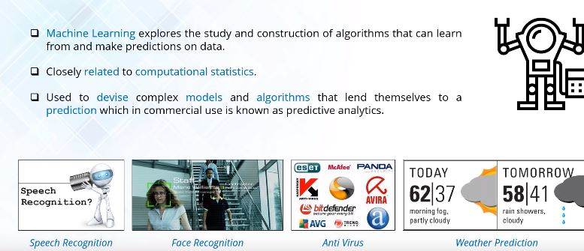

**What is Naive Bayes ?**

Naive Bayes is a simple but surprisingly powerful algorithm for Predictive Modeling. It is a Classification technique based on Bayes Theorem with an assumption of independence among predictors.

It comprises of two parts which is Naive (showing a lack of experience, as it assumes that one feature in a model is independent of existence of another feature) and Bayes, in simple terms Naive Bayes Classifier assumes that the presence of a particular feature in a class is unrelated to the presence of any other feature, even if this features depend on each other or upon the existence of the other features all of these properties independently contribute to the Probability.

Something like whether a fruit is an apple or an orange or a banana, look at these two events in relationship with one another, so that is why Naive Bayes is particularly used for Large datasets.

The name naive is used because it assumes the features that go into the model is independent of each other. That is changing the value of one feature, does not directly influence or change the value of any of the other features used in the algorithm.

Conditional Probability:

If you pick a card from the deck, can you guess the probability of getting a queen given the card is a club?

Well, I have already set a condition that the card is a club. So, the denominator (eligible population) is 13 and not 52. And since there is only one queen in spades, the probability it is a queen given the card is a spade is 1/13 = 0.077

This is a classic example of conditional probability. So, when you say the conditional probability of A given B, it denotes the probability of A occurring given that B has already occurred.

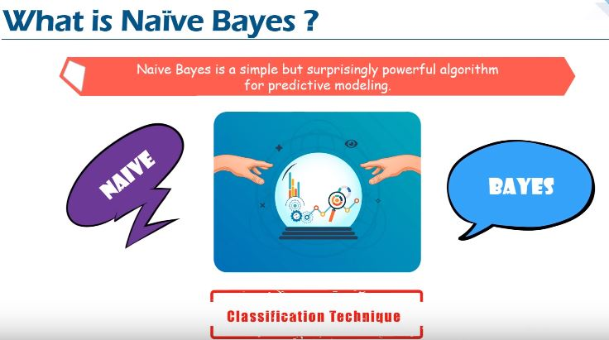

**Bayes Theorem :**

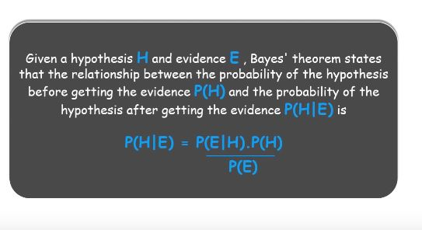

Bayes Theorem is a way to figure out Conditional Probability where Conditional Probability is Probability of an event happening given that it has some relationship to one or more other events.

Let’s take an example to make it more clear as follows :

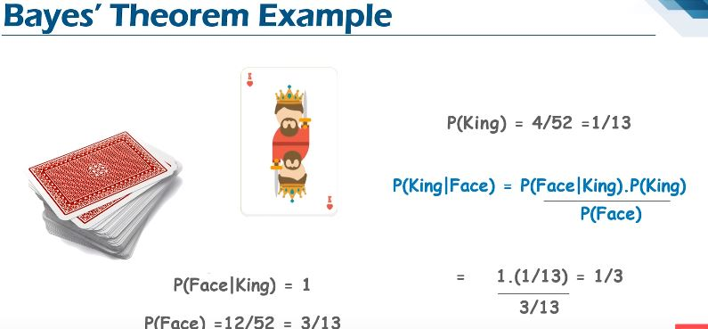

So finally we can wrap as there will be 3 faces (Jack,King and Queen) the probability of picking King as Face will be ⅓ same matched above .

We can wrap as follows :

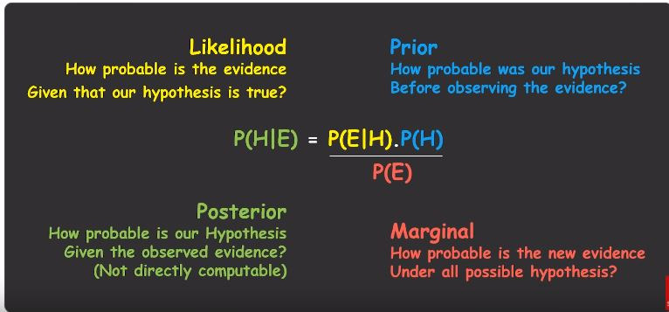

**Industrial Use of Naive Bayes :**



**Companies use Web Crawlers to useful extract text from HTML Pages ,the news articles and each of these news article is tokenized these tokens are nothing but the categories of news,in order to achieve better significant result we remove the less significant which are the “Stopwords”from the documents or the articles,and then we apply the Naive Bayes Classifier,the news content based on News Code.**

**Object Detection is the process of finding instances of real world objects such as faces,bicycles and buildings in images or video.As Object Detection Algorithm typically use extracted features and learning algorithm to recognize instance of an object category where Naive Bayes play an important role of categorization and classification of objects.**

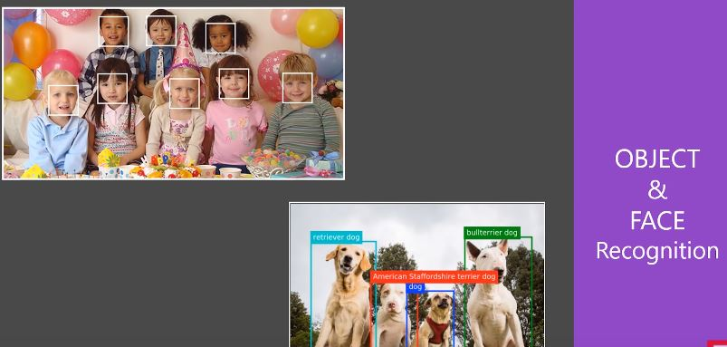



All the available information is used to explain the decision this explanation seems to be natural for Medical Diagnosis which is very close to the way Physician diagnose the patients.



A biasing approach based model is created by where posterior probabilities are used to calculate the likelihood of each class label for input data instances and the one with the maximum likelihood is considered as the resulting output .

Types of Naive Bayes in scikit-learn :

1)Gaussian - It is used in Classification and it assumes that the feature follow our Normal

Distribution.

**Gaussian Naive Bayes classifier**

In Gaussian Naive Bayes, continuous values associated with each feature are assumed to be distributed according to a **Gaussian distribution**. A Gaussian distribution is also called [Normal distribution](https://en.wikipedia.org/wiki/Normal_distribution). When plotted, it gives a bell shaped curve which is symmetric about the mean of the feature values as shown below:

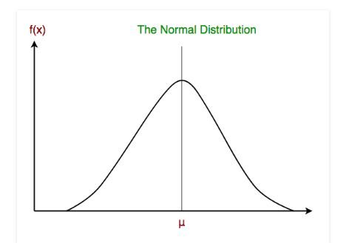

The likelihood of the features is assumed to be Gaussian, hence, conditional probability is given by:



2)Multinomial - It is used for Discrete Counts for eg: We have a Text Classification Problem where we consider trials and checking the word occurring in the document we have count ,how often the word occurs in the document.

3)Bernoulli - Binomial Model is useful if your feature vectors are are binary bag of words model,by checking word which occur in the document and which don’t occur in the document by taking zeros and ones.

Steps involved in Naive Bayes :

**Step 1 : Handling data - We load the data from csv file and spread it into training and tested assets**

**Step 2 : Summarizing data - We summarize the properties in the training dataset so that we can calculate the probabilities and make predictions**

**Step 3 : Making a Prediction - Making a particular prediction,where we use the summaries of generate a single prediction and after that we generate predictions given a test dataset and a summarized training dataset.**

**Step 4 : Evaluate Accuracy - We evaluate the accuracy of the predictions made for a test dataset as a percentage correct out of all the predictions made and finally we tie together and form our own model.**